**SCM Flow**

%TOC%

**Goal**

The goal is to

1. Enable multiple Developers to work on same project simultaneously
2. Enable different teams to work on same product at same time
3. Enable different projects to deliver multiple products
4. Reduce overall time to launch product

In order to achieve above goals we are introducing SCM workflow.

**Current Release flow**

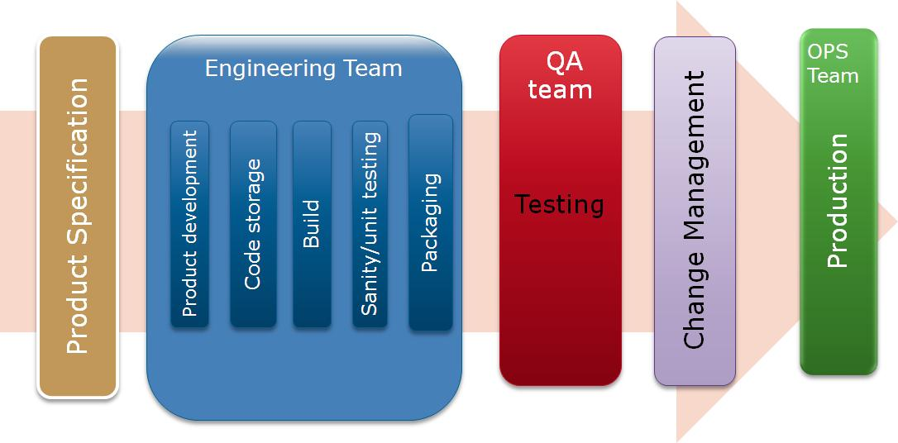

**Challenges**

1. Difficult for various team members to work on multiple releases
2. Creates friction between Developers working on different teams
3. Increases sprint time to release

**SCM Workflow**

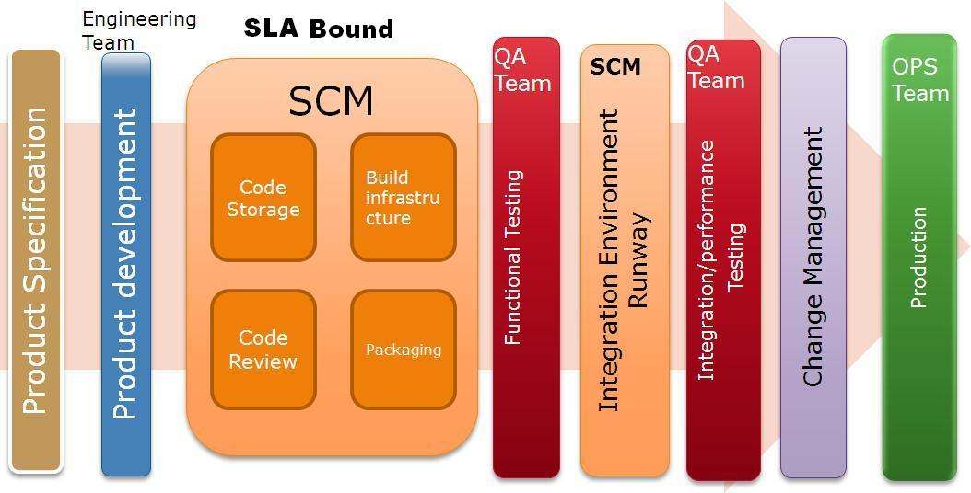

**Benefits**

1. Separation of work in different stages of release
2. Clear ownership of tasks among different stages
3. Clear and define process

**SCM Flow and Core components**

[[SCMFlowComponents][ SCM Flow in detail and core components]]